Proposal for {{ q19\_mainContact19.field\_3 }}

{{ q17\_companyName }} - {{ q27\_projectName }} - Specification Review Document

Contents

[Relevant Parties 4](#_Toc38099843)

[Scope 5](#_Toc38099844)

[5](#_Toc38099845)

[Out of Scope 5](#_Toc38099846)

[5](#_Toc38099847)

[Assumptions 6](#_Toc38099848)

[Key Assumptions 6](#_Toc38099849)

[Costing Summary 7](#_Toc38099850)

[Additional Comments 8](#_Toc38099851)

[Resources 9](#_Toc38099852)

[Prepaid Rates Conditions 9](#_Toc38099853)

[APPENDIXES 10](#_Toc38099854)

[SSW Agile Process 10](#_Toc38099855)

[SSW Scrum Master 10](#_Toc38099856)

[Sprint Backlog 10](#_Toc38099857)

[Product Backlog 10](#_Toc38099858)

[Product Backlog Items (PBIs) 10](#_Toc38099859)

[Review and Retrospective 11](#_Toc38099860)

[User Acceptance 11](#_Toc38099861)

[During development 11](#_Toc38099862)

[Users involved at each step in the process 11](#_Toc38099863)

[SSW Design 12](#_Toc38099864)

[UX - User Experience 12](#_Toc38099865)

[Design Process 12](#_Toc38099866)

[More about SSW 13](#_Toc38099867)

[Our Key People 13](#_Toc38099868)

[Certifications 13](#_Toc38099869)

[Our Services 14](#_Toc38099870)

[Our Values 14](#_Toc38099871)

[Our Technical Standards 14](#_Toc38099872)

[Contact Us 14](#_Toc38099873)

[Case Study 15](#_Toc38099874)

[Toll Transport Fleet Management System proudly developed by SSW 15](#_Toc38099875)

[We make complicated things simple 15](#_Toc38099876)

[Results 16](#_Toc38099877)

**Dear {{ q19\_mainContact19.field\_3 }}**

Thank you for the opportunity to review your development requirements.

As per our conversation, this document outlines our proposal to build the {{ q27\_projectName }} system.

The following estimate is based on our current understanding of your requirements from the information you have given us. Actual work may vary from the estimated times.

These estimates are valid for 30 days from date of issue. After this, the rates and estimates are subject to change.

The resources allocated to your project depend on availability. All efforts will be made to allocate the original resources used on the Spec Review, but that cannot be guaranteed.

I look forward to your feedback.

Yours sincerely,

{{ q36\_yourName.first }} {{ q36\_yourName.last }}

{{ q38\_yourTitle }}

[www.ssw.com.au](http://www.ssw.com.au/)

# Relevant Parties

|  |  |  |  |
| --- | --- | --- | --- |
| Name | Company | Project Role | Contact |
| {%tr for p in q35\_projectStakeholders\_parse %} | | | |
| {{ p.Name }} | {{ p.Company }} | {{ p.Role }} | {{ p.Email }}  {{ p.Mobile }} |
| {%tr endfor %} | | | |

# Scope

{% for area in q39\_majorFeatures\_parse %}

## **{{ area.Name }}**

{{ area.Description }}{% endfor %}

# Out of Scope

The following items have not been considered within the estimates. Should the need arise, SSW can work on these on an ad-hoc basis. {% for out in q40\_outOfScope\_parse %}

## {{ out.Name }}

{{ out.Reason }}{% endfor %}

# Assumptions

{% for out in q42\_assumptions\_parse %}

## {{ out.Name }}

{{ out.Description }}{% endfor %}

# Costing Summary

Note: All numbers are ex. GST

|  |  |  |
| --- | --- | --- |
| task | Est. effort (hr) | is mvp |
| {%tr for t in q34\_listOfPbi\_parse %} | | |
| {{ t.PBI }} | {{ t.Estimated\_Hours }} | {{ t.Is\_MVP }} |
| {%tr endfor %} | | |

{% if q26\_allRequirements == ‘NO’ %}

**NOTE:** Full requirements of the system have not been identified. Future sprint planning will be required

{% endif %}

**Total Estimated Hours: {{ q41\_totalEstimate.field\_1 }}**

**Total Estimated Cost (standard rate): ${{ q41\_totalEstimate.field\_3 }}.00**

**Total Estimated Cost (prepaid rate): ${{ q41\_totalEstimate.field\_4 }}.00**

{% if q8\_additionalComments %}

# Additional Comments

{{ q8\_additionalComments }}

{% endif %}

## Resources

The estimates above are based on the following resources being allocated to your project, although this may change:

|  |  |  |  |
| --- | --- | --- | --- |
| https://sharepoint.ssw.com.au/AboutUs/Employees/PublishingImages/WilliamLiebenberg-Profile-Square-Color.jpg | william Liebenberg SSW Solution Architect | Standard Hourly Rate | Prepaid Hourly Rate |
| $285 + GST | $270 + GST |
| https://sharepoint.ssw.com.au/AboutUs/Employees/Pages/WilliamLiebenberg.aspx | | |
| https://sharepoint.ssw.com.au/AboutUs/Employees/PublishingImages/Anthony-SSW-inside-page-square.jpg | Antony Nguyen SSW Solution Architect | Standard Hourly Rate | Prepaid Hourly Rate |
| $285 + GST | $270 + GST |
| https://sharepoint.ssw.com.au/AboutUs/Employees/Pages/AnthonyNguyen.aspx | | |
|  | Alex Breskin SSW Software Architect | Standard Hourly Rate | Prepaid Hourly Rate |
| $205 + GST | $190 + GST |
| <https://sharepoint.ssw.com.au/AboutUs/Employees/Pages/Alex.aspx> | | |

## Prepaid Rates Conditions

SSW offers a competitive rate to those clients pre-paying time in blocks of 40 hours per Project Team Member. Pre-paid rates take effect on day of payment.

Rates revert to standard if pre-payment is not maintained.

For continuing work a new invoice will be issued when more than half the hours of the previous invoice have been consumed. We recommend that you are able to process payment within 24 hours of receiving invoice to maintain pre-payment. Credit-Card and Direct Deposit only. See <http://www.ssw.com.au/ssw/Company/AboutUs.aspx#Bank> for SSW banking details.

# APPENDIXES

## SSW Agile Process

SSW will engage in the following process to develop the system in 1 or 2 week Sprints.

## SSW Scrum Master

An SSW Scrum master’s job is to ensure that the Scrum process is being followed well and to help remove any impediments that might slow down development

* Ensure Daily Scrums happen and are effective
* Facilitate Review, Retrospective, and Planning meetings
* Liaise with the Product Owner (normally the client) to ensure the developer team is working from their priority list.

## Sprint Backlog

A Sprint Backlog details all the tasks to be completed over a fixed period, normally 2 weeks. At the end of every Sprint, the aim is to provide useful functionality to users for an internal UAT or rollout to production.

The items added to the current Sprint are based on the priority given to tasks by the Product Owner, and the Sprint plan is approved by the client before work on the Sprint begins.

## Product Backlog

Tasks that are not in the current release due to lower priority or because of dependencies with features that are not yet implemented are listed in the Product Backlog. This list of tasks allows the client to review items left to do, and the order of the Product Backlog should reflect the Product Owners priorities.

Tasks are added to the Product Backlog as soon as they are raised by either the client or SSW during a Sprint, and the Product Owner will order them according to priority level.

## Product Backlog Items (PBIs)

PBIs can be expressed as User Stories. These describe the functionality of the new system from the User’s point of view. They outline the way the system works and the process flow. They will be listed in the TFS Product Backlog.

## Review and Retrospective

The Review and Retrospective occur at the end of each Sprint. The outcomes of this meeting are:

* Each PBI is demonstrated and either marked as Done or returned to the Product Backlog to be re-prioritised.
* All team members give feedback on what is and isn’t working, and changes to the process are agreed for the next release.
* Discussions around the business’s commitment and resource allocation to the project
* Assessment of the estimated time left to complete the project

## User Acceptance

User acceptance is integrated into the whole process. Testing should run concurrently to development.

### During development

Once the development process begins, the Scrum Master will hold Daily Scrum (phone) meetings and regular in person meetings with the Software Architects to confirm the specification is on track with the business expectations.

### Users involved at each step in the process

At the end of each Sprint during the project, the system is sent to stakeholders (or the Product Owner) for testing and signoff.

# SSW Design

## UX - User Experience

The term "user experience" refers to a concept that places the end-user at the focal point of design and development efforts, as opposed to the system, its applications or its aesthetic value alone. It's based on the general concept of user-centered design.

True user experience goes far beyond giving customers what they say they want, or providing checklist features. In order to achieve high-quality user experience in a company's offerings there must be a seamless merging of the services of multiple disciplines, including software engineering, marketing, graphical and interface design.

The skillset of a user experience consultant combines the knowledge of a strong design principles and technical understanding to produce an engaging experience for the user unattainable by either a designer or developer.

## Design Process

**Figure**: The SSW design process enables intuitive user interfaces, which make user acceptance a reality

# More about SSW

SSW is a Sydney-based consulting company specialising in .NET solutions for progressive businesses since 1990. SSW offers custom software solutions including data-driven websites & windows applications. SSW utilises the latest Microsoft technologies including ASP.NET, C#, SQL Server, XML, Microsoft CRM, Exchange Server and SharePoint.

## Our Key People

SSW is led by Adam Cogan, Chief Architect and one of only three Australian Microsoft Regional Directors. His expertise helps SSW deliver cutting edge Microsoft technology solutions. Our staff in Australia, Europe, Brazil and China satisfies a range of clients around the world.

|  |  |  |  |  |
| --- | --- | --- | --- | --- |
| employeephotos_adam.jpg | uly | employeephotos_marlon.jpg | employeephotos_eric.jpg | employeephotos_cameron.jpg |
| mark | employeephotos_tiago.jpg | stevo |  | mehmette |

## Certifications

We're proud of our long-standing commitment to quality in the services we provide. At SSW, we have Microsoft Gold Certified Competencies, MVPs and Regional Directors.



## Our Services

SSW can help you leverage your investment in technology to capitalise on your own competitive advantages. Our knowledge and expertise with market leading technology allows us to develop a tailored solution to your business requirements and thus allow you to focus on your own core competencies. Our goal is to develop flexible and scalable solutions aimed at achieving your objectives.

With a proven track record of implementing technology solutions ranging from Architecture and Design Consulting to Database Development and Business Intelligence Solutions. SSW works alongside you to leverage the latest technological advances to reduce costs, improve processes, and take advantage of new business every step of the way.

Based upon years of experience working closely with Microsoft, SSW software development services utilise the best available technologies to deliver functional, value-adding software - faster.

## Our Values

At SSW our aspiration is to provide innovative solutions for our clients, focusing on Microsoft products, in particular ASP.NET MVC, SharePoint, SQL, CRM and TFS. To achieve this vision, we pride ourselves on our skills, professional attitude and rapid acquisition of new technologies.

SSW’s values:

* Integrity and honesty
* Best practices and consistency
* Communication and transparency

## Our Technical Standards

SSW follows a series of technical standards of best practices for application development and project management. These can be found at <http://www.ssw.com.au/SSW/Methodology/Rules.aspx>

## Contact Us

SSW   
Gateway Court Suite 10   
81 - 91 Military Road   
Neutral Bay, Sydney NSW 2089 Australia

Phone: + 61 2 9953 3000   
Email: [info@ssw.com.au](mailto:info@ssw.com.au)   
Web: [www.ssw.com.au](http://www.ssw.com.au/ssw/)

# Case Study

## Toll Transport Fleet Management System proudly developed by SSW

Toll Transport is Australia’s largest logistics and trucking companies. Toll comprises a network of businesses that work individually and collectively to deliver optimal logistics solutions across all industry sectors.

Toll was looking to track and understand the movements of their Toll Linehaul fleet across the country. They needed to optimise the travel to reduce costs, meet government compliance, and manage their trucks and drivers.

### We make complicated things simple

Toll’s scheduling process was very complicated due to trucks, drivers, and trailers all changing mid route.

SSW created a user friendly interface for scheduling staff to set routes for trucks more efficiently. We integrated a mobile solution, GPS tracking, and Google maps into the solution, so the data collected could be used to make better business decisions in real time.

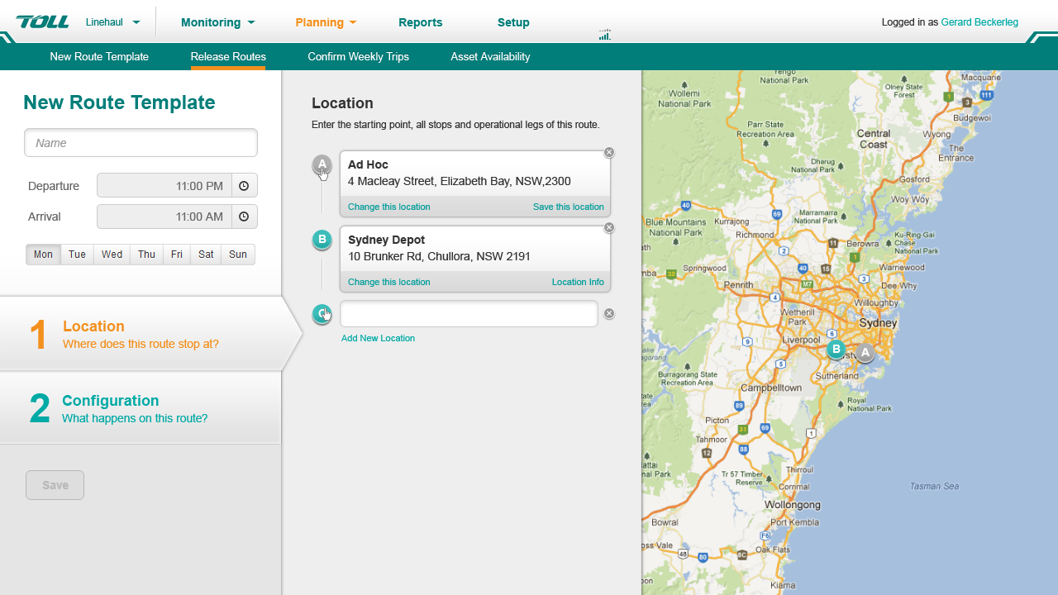

Figure: The scheduling board

### Results

Toll was able to meet their compliance requirements and understand the location of their drivers when emergencies occurred, and inform their clients of delays in real time. Something they could not do in the past.

This has revolutionised their business.